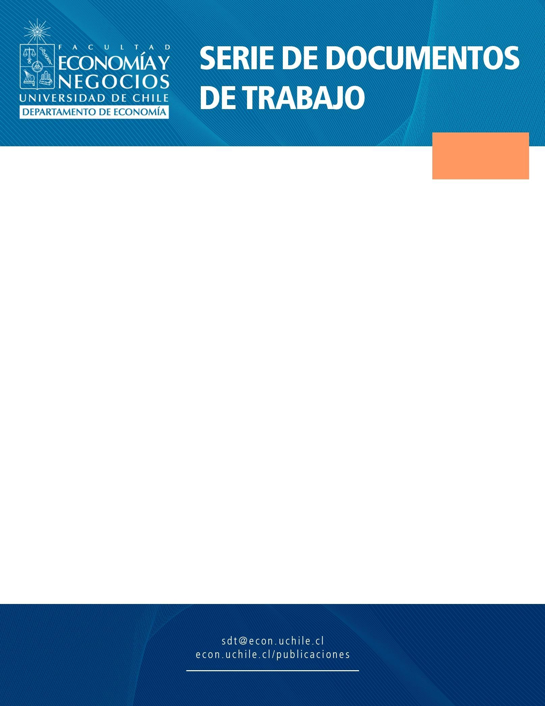
Thelekmolemeo
SDT 533

What is the Effect of Domestic Demand Shocks on Inflation in a Small Open Economy? Chile 2000-2021

Autores:
Ramón López
Kevin Sepúlveda

Santiago, Mayo de 2022

